SpaceAdherenceMission(SAM) - CADRe Part A

Office of the Chief Financial Officer (OCFO)
Cost Analysis Data Requirements (CADRe)
PART A
Mission : SpaceAdherenceMission
Design Reference : EDA
Key Decision Point : CDR
EPMO Gate : Gate-R3
Draft 2.0 (Integrated Part C / Part D consistency update)
September 22, 2026

This Page Intentionally Left Blank
Revision History
Rev. | Description | Prepared by | Date
Draft 1.0 | Initial draft | Person A | 17 Sept 2026
Draft 2.0 | Integrated finalized CADRe Part C / Part D assumptions; reconciled architecture, schedule, procurement, operations, and quantitative mission drivers. | Person A | 22 Sept 2026

Table of Contents
This Page Intentionally Left Blank
1 Introduction 7
1.1 Purpose of this document 7
1.2 Purpose and scope of mission 7
2 General Descriptive Information 8
2.1 Mission Overview 8
2.2 Context 10
2.3 Strategic Objectives 11
2.4 Selected Mission Requirements 11
2.5 High-Level Mission Architecture 13
3 Space Segment Description 15
3.1 Spacecraft Bus 15
3.2 Payload 20
4 Launch Segment Description 29
5 Ground Segment and Mission Operations 31
6 Systems Engineering and Project Management Approach 32
6.1 TRL Levels and Heritage 32
6.2 Phasing Logic and Naming Conventions 32
6.3 CSA Project Milestones 32
6.4 Safety and Mission Assurance 33
6.5 Qualification and Acceptance Strategy, Model Philosophy 33
6.6 Risk Assessment 34
6.7 Organizational Breakdown Structure 34
Appendices 36
A Acronym List 37

List of Figures
FIGURE PAGE
Figure 1 – SAM Mission Concept 9
Figure 2 – Notional Spacecraft Power-System Examples 19
Figure 3 – Notional ADCS Components 25
Figure 4 – Launch Configuration 29
Figure 5 – Ground Receiving Stations 31

List of TABLES
Table 1 – Strategic Alignment 11
Table 2 – Selected Mission Requirements 11
Table 3 – Preliminary SAM Spacecraft Allocation and Reference Data 17
Table 4 – CSA Project Milestones 32

Introduction

Purpose of this document
CADRE Part A provides a concise, standardized synopsis of the mission or project to support costing and analysis activities. Its primary purpose is to consolidate information from multiple technical and programmatic source documents into a single, normalized reference.
Specifically, CADRE Part A:
- Summarizes key mission characteristics in a consistent and structured format
- Aggregates information drawn from multiple authoritative technical documents
- Reduces the need for analysts to repeatedly consult disparate source materials
- Ensures a common baseline description is used across analyses
- Improves efficiency, traceability, and consistency in downstream costing work
In practical terms, CADRE Part A functions as a time-saving reference document that enables analysts to quickly understand the mission context without re-interpreting or reconciling multiple source documents.

Purpose AND SCOPE of MISSION
Space Adherence Mission (SAM) is a Canadian Earth-observation mission intended to provide persistent, repeatable space-based information supporting Canadian situational awareness, surveillance, and monitoring in the Arctic and northern maritime approaches. The mission is government-led, owned and operated by the Canadian Space Agency (CSA), in collaboration with the Department of National Defence (DND).
The mission responds to the increasing strategic, transportation, environmental, and commercial significance of the Canadian Arctic. Declining seasonal sea ice and increasing activity in northern waterways increase the value of persistent observations of vessels, sea-ice conditions, infrastructure, transportation corridors, and changes in the coastal and terrestrial environment.
SAM is intended to provide an independent Canadian space-based sensing capability that complements existing terrestrial, airborne, maritime, allied, and commercial information sources. The two-spacecraft architecture is intended to provide coordinated and near-continuous observation of designated Arctic areas of interest while maintaining Canadian control of mission operations and mission data.
The project is conceptually inspired by Canada's SAPPHIRE military satellite program, particularly its government-industry delivery model, dedicated operational ground segment, mission-assurance approach, and long-duration government operations. SAPPHIRE is treated as a programmatic heritage reference rather than a direct technical or cost analogue because SAM is an Earth-observation mission with a different payload, orbit, ground segment, and operational concept.

General Descriptive Information

Mission Overview
The Space Adherence Mission (SAM) is a proposed two-spacecraft Earth-observation mission designed to provide persistent, repeatable observations of Canada's Arctic and northern maritime approaches.
SAM is intended to complement existing Canadian surveillance and information systems by providing observations over geographically extensive and sparsely populated regions where conventional terrestrial surveillance infrastructure is limited.
The two SAM spacecraft will operate as a coordinated constellation in a highly elliptical, high-inclination orbit selected to maximize dwell time over the Canadian Arctic. The preliminary reference orbit uses a low-altitude portion near 550 km with an inclination of at least 85 degrees; final apogee, orbital period, phasing, and observation geometry remain subject to mission analysis.
The mission's broad observation objectives include:
- Arctic maritime activity;
- sea-ice distribution and seasonal changes;
- northern transportation corridors;
- selected infrastructure;
- changes in coastal and terrestrial environments; and
- other government-defined areas of interest.
The system consists of two substantially similar spacecraft, Earth-observation payloads, a commercial launch service, government and contractor-provided ground infrastructure, mission-control and planning systems, data-processing and archive capability, 24-hour government mission operations, and associated project-management, assurance, and sustainment activities.
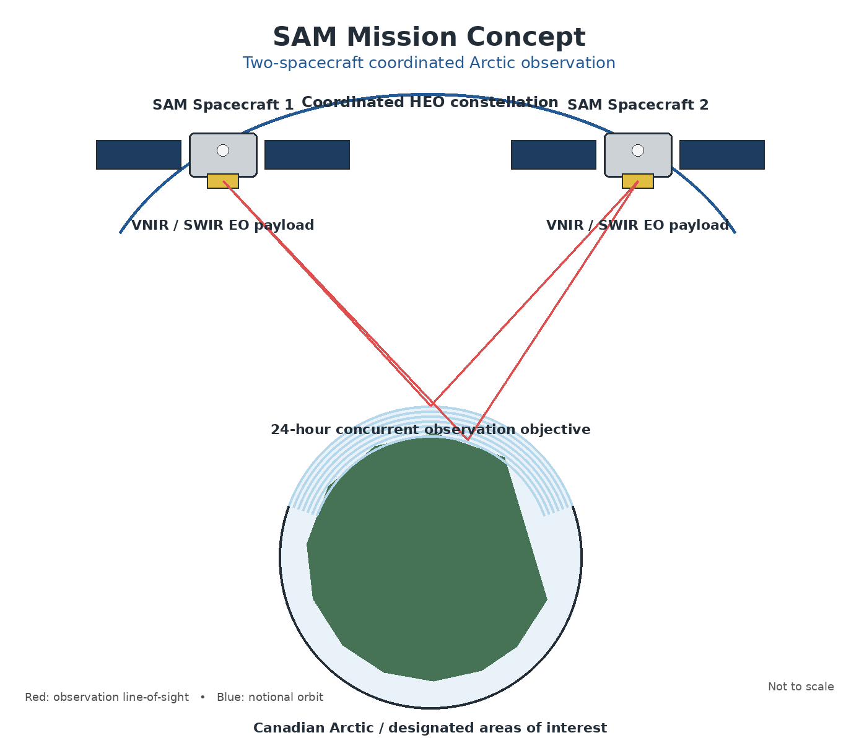
Figure 1 – SAM Mission Concept

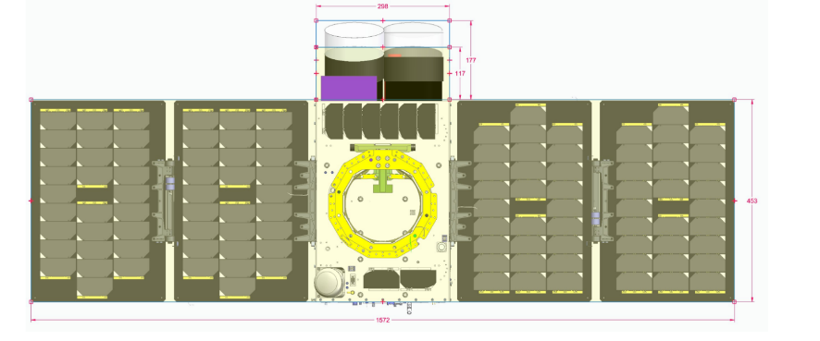
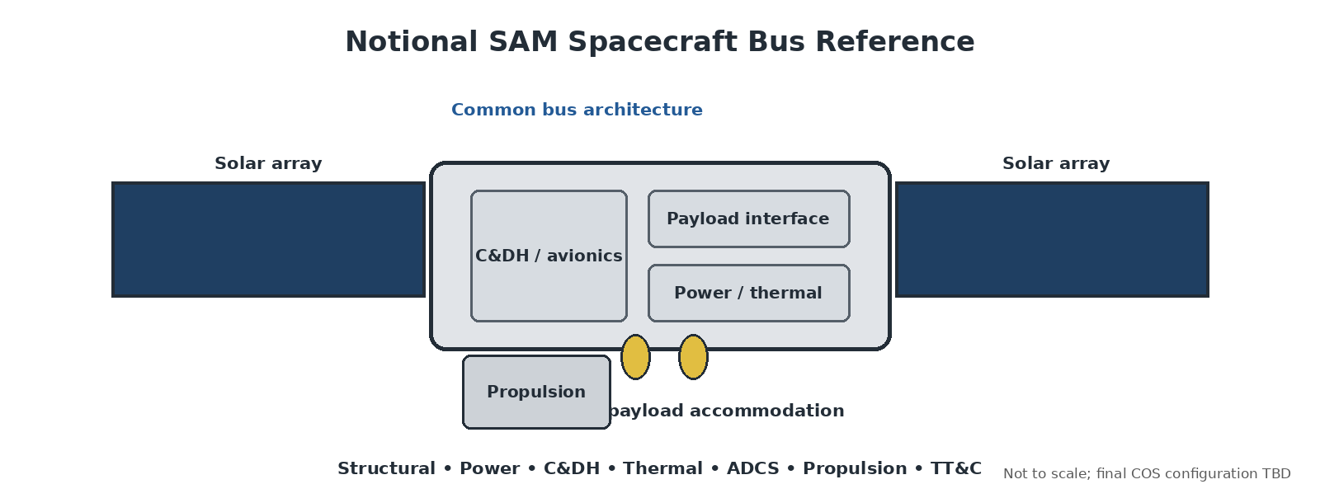

Context
The conceptual mission draws organizational and programmatic inspiration from SAPPHIRE, Canada's space-based surveillance satellite developed for DND. SAPPHIRE demonstrates relevant Canadian heritage in military space operations, spacecraft development, government-industry cooperation, satellite ground operations, mission assurance, and long-duration spacecraft operations.
SAPPHIRE demonstrates relevant Canadian heritage in:
- military space operations;
- spacecraft development;
- government-industry cooperation;
- satellite ground operations;
- mission assurance; and
- long-duration spacecraft operations.
SAPPHIRE's mission and sensor architecture were substantially different from the proposed SAM Earth-observation mission. It is therefore used only as a programmatic heritage reference; the SAM cost and schedule baseline is driven by the SAM architecture, current PM schedule, procurement model, and finalized CADRe Part C / Part D assumptions.
Reference industry responses and market observations are retained only as concept-development evidence; they do not establish SAM procurement partners. The finalized procurement baseline is defined in CADRe Part D and identifies CSA, COS, NorthStar Imaging Technologies, Earth Daily Analytics, Northern Launch Services, and Canadian university/research institutions as the relevant organizations.
The SAM CADRe baseline in this document is the controlling Part A reference for the current cost estimate. Any change to the mission architecture, schedule, procurement model, or organizational baseline shall be reconciled with the finalized CADRe Part C and Part D documents.
Reference Industry Responses – Not SAM Procurement Baseline
Prime | Constellation Size | Bus | P/L
SPIRE | 7 cubesats | Spire 8U Lemur2 | OroraTech
Earth Daily Analytics | 4 smallsats | SFL Defiant | ABB
Magellan | 4 smallsats | Magellan MAC-150 | ABB
GHGsat | 4 smallsats | SFL | ABB
Kepler | Commercial Data Buy | Kepler | ABB

Strategic Objectives
Consistent with the Government of Canada's Space Policy Framework, SAM is intended to use space-based observations to improve Canadian sovereign security, surveillance, and monitoring of the Arctic and northern approaches, support defence operations and government decision-making, and reduce uncertainty associated with Arctic vulnerabilities.
Table 2 - Strategic Alignment
 | Strategic Goals | Space Strategy
1 | SOLVE | SAM will use a Canadian space-based Earth-observation capability to improve sovereign security, surveillance, and monitoring; support defence operations and government decision-making; and provide persistent information for the Arctic operating environment.

Selected Mission Requirements
The following table consolidates the quantitative mission parameters that are significant drivers of mission cost, schedule, risk, and technical complexity. The values are a preliminary SAM estimating baseline intended to remain consistent with the finalized Part C schedule, procurement model, RAM/LOE structure, and Part D organizational and configuration baselines. The Mission Requirements Document remains authoritative; TBD items are to be closed through the applicable design reviews.
Table 2 – Selected Mission Requirements
Area | Key requirement
Arctic coverage | Observation capability over designated Canadian Arctic areas of interest covering a planning area of up to 4 million km².
Orbit | Two spacecraft shall operate as a coordinated, high-inclination HEO constellation optimized for Arctic dwell; the preliminary reference low-altitude portion/perigee is approximately 550 km and inclination shall be ≥85°. Final apogee, orbital period and phasing are subject to mission analysis.
Observation continuity | The two-spacecraft constellation shall support a 24-hour concurrent observation objective over designated Arctic areas of interest.
Mission lifetime | Minimum operational mission life of 5 years after commissioning; design objective of 7 years; consumables sized for at least 7 years.
Spacecraft launch mass | ≤600 kg per spacecraft including propellant; preliminary target of 500 kg.
Payload mass allocation | ≤150 kg per spacecraft including payload electronics and associated thermal/mechanical provisions.
Payload power | Payload allocation of at least 500 W continuous and 750 W peak, subject to final payload and spacecraft power-budget closure.
Spatial resolution | Primary imaging payload shall provide GSD ≤5 m under defined reference imaging conditions.
Imaging swath | Payload shall provide an imaging swath width of at least 50 km under nominal operating conditions.
Pointing accuracy | Absolute pointing error target ≤0.05° during imaging operations.
Radiometric performance | VNIR absolute radiometric accuracy target of ±10%; SWIR radiometric accuracy to be finalized through the payload trade study. A thermal-infrared baseline is not assumed.
Geolocation | Level-1B products shall be georeferenced to within 0.5 of the applicable imaging-channel instantaneous field of view at 95% confidence.
On-board storage | Each spacecraft shall provide at least 1 TB of usable non-volatile mission-data storage.
Mission-data downlink | High-rate X-band mission-data downlink target of ≥500 Mbps peak; effective throughput shall be demonstrated by the final link budget and ground-contact analysis.
Mission-data volume | Planning case of approximately 125 GB/day of downlinked mission data per spacecraft, or approximately 250 GB/day for the two-spacecraft constellation.
Canadian data latency | For designated priority observations, a processed mission product shall be available within 6 hours of receipt of the associated raw data by the ground segment.
Government data access | Authorized Government of Canada users should receive access to released mission products within 30 minutes of product generation, subject to security controls.
Tasking cadence | Observation schedules shall be generated and/or uploaded at least once every 24 hours during nominal operations.
Autonomous operation | Each spacecraft shall support at least 72 hours of autonomous operation without ground intervention.
Space-segment availability | At least 90% monthly space-segment availability during the nominal mission.
Ground processing and archive | Ground processing shall be sized for at least 1 TB/day of raw-data-equivalent processing capacity; archive retention shall support at least 5 years, with a preliminary planning capacity of approximately 2 PB including processed products, metadata, and redundancy.
Ground-system availability | Ground systems shall provide ≥99% availability during scheduled operational periods.
Data integration | Standardized data and metadata interfaces shall support integration with at least 3 authorized external Government of Canada systems.
Mission reliability | Preliminary 5-year mission-success probability target of ≥0.85 for cost and risk analysis; final reliability allocation to be established by the Mission Requirements Document and reliability program.
Mass and power margins | Preliminary design margins of ≥20% on nominal mass and ≥20% on nominal power, with ≥10% margin for peak-power conditions.
Technology readiness | Major spacecraft-bus components should reach TRL ≥8 before flight qualification; critical payload technologies should be at least TRL 6 at the start of B2 development and TRL ≥8 before flight qualification.
Launch readiness | Commercial launch service shall support deployment of both spacecraft into the selected HEO; launch-campaign duration after delivery to the launch site is planned not to exceed 9 months.
Commissioning | Operational readiness is targeted within 90 days of launch, subject to successful LEOP, spacecraft checkout, payload activation, calibration, and constellation coordination.
End of life | A controlled disposal strategy shall be implemented at end of operations; the propulsion budget includes 40 m/s allocated to deorbit.

High-Level Mission Architecture
Owned and operated by CSA, in collaboration with the Department of National Defence, the mission consists of:
- A Government Segment: CSA project management, systems engineering, payload authority, mission planning, mission operations, governance, security, and technical oversight, with DND as the principal defence stakeholder.
- A Space Segment: two substantially similar spacecraft, each with a common bus and a VNIR/SWIR Earth-observation payload, operated as a coordinated constellation in the selected HEO.
- A Launch Segment: a commercial launch service procured for the two-spacecraft constellation; Northern Launch Services is the current launch-service organization in the SAM procurement baseline.
- A Ground Segment: contractor-provided and integrated infrastructure for mission planning, spacecraft control, receiving stations, data processing, calibration, quality control, archiving, and secure dissemination. Earth Daily Analytics provides and integrates the required ground-segment elements.
- An Ops Segment: Government of Canada personnel performing 24-hour mission operations, including monitoring, command execution, anomaly response, orbit and attitude monitoring, mission planning, and coordination of the two spacecraft.
- A Science Segment: Canadian scientific leadership, university/research teams, and supporting infrastructure for calibration and validation, data analysis, scientific data products, user support, and scientific exploitation of SAM observations. No international science partner is assumed in the baseline.

Space Segment Description
The space segment consists of a constellation of 2 spacecrafts, each with a bus and a payload.

Spacecraft Bus
The SAM spacecraft bus will provide the structural, electrical, thermal, computational, communications, attitude-control, and propulsion functions required to operate the Earth-observation payload in the selected HEO. The bus design shall support a common architecture across both spacecraft and the mission-level requirements for storage, autonomy, pointing, communications, lifetime, and end-of-life disposal.

Two substantially similar spacecraft will be developed to reduce non-recurring engineering, manufacturing complexity, and operations cost. The spacecraft will share a common bus architecture while allowing payload-specific equipment and software to be accommodated as required. The same qualified design will be used for Flight Model 1 and Flight Model 2, with each flight unit undergoing its own acceptance verification.

Key functions of the bus include:
- Structural subsystem
- Electrical power generation and distribution
- Command and Data Handling (C&DH)
- Thermal subsystem
- Attitude Determination and Control System (ADCS)
- Propulsion subsystem
- Telemetry, Tracking and Command (TT&C)
Reference design note: the detailed component examples that follow were adapted from an EDA/DEFIANT small-spacecraft reference and are used only as notional heritage for first-order costing. They are not SAM flight allocations. The current SAM baseline is controlled by the quantitative mission requirements, COS bus procurement, and Part C / Part D baselines.
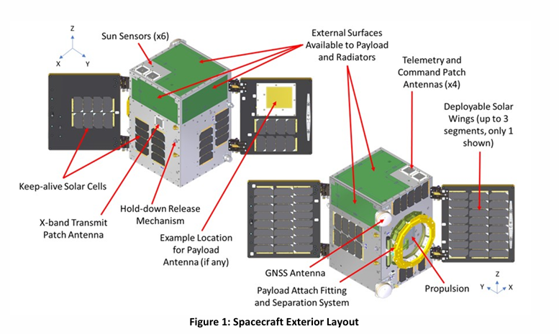
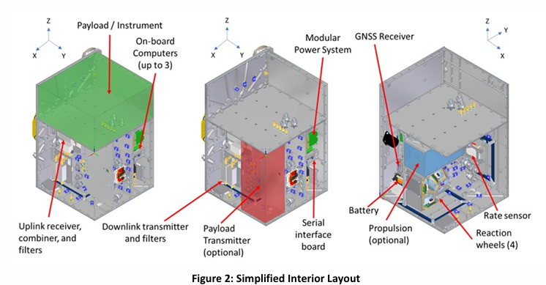

Structural Subsystem
Reference structural architecture: aluminum-alloy primary structure with CFRP/aluminum-honeycomb deployable-panel concepts. Final material selection, structural sizing, and mass properties are to be established by COS within the SAM mass allocation and verification baseline.
The structure is comprised of aluminum alloy. Deployable panels are made of CFRP and aluminum honeycomb core
Parameter | Preliminary SAM allocation / target
Spacecraft launch mass | ≤600 kg per spacecraft including propellant
Target launch mass | 500 kg per spacecraft
Payload allocation | ≤150 kg per spacecraft
Mass margin | ≥20% at the applicable design baseline
Mission-data storage | ≥1 TB usable per spacecraft
Autonomous operation | ≥72 hours without ground intervention
Absolute pointing accuracy | ≤0.05° during imaging
Reference low-altitude orbit region | ~550 km; final HEO apogee/perigee and period TBD
Propulsion delta-V budget | 99.6 m/s total preliminary budget, including contingency
End-of-life deorbit allocation | 40 m/s
Combined spacecraft launch mass allocation | ≤1,200 kg for two spacecraft
Target combined spacecraft launch mass | ~1,000 kg for two spacecraft

The spacecraft electrical-power system shall be sized to close the end-of-life power budget while maintaining at least 20% nominal power margin and at least 10% margin at peak-power conditions. Solar-array sizing shall account for the HEO thermal and illumination environment, payload power demand, communications loads, battery recharge, and degradation over the nominal 5-year mission.
Solar Array Panels
- Two deployable solar-array panels are retained as a reference architecture; the final array area and cell/string configuration shall be sized by COS from the verified SAM power budget rather than copied directly from the DEFIANT reference configuration.
- End-of-life power generation shall be sufficient to meet the verified mission power budget with the specified design margin.
- The power system shall be sized for the payload, high-rate X-band data transmission, spacecraft housekeeping, thermal-control loads, and battery recharge requirements over the relevant HEO operating cases.
Battery
- A lithium-ion battery system is assumed for the preliminary design, with capacity derived from the worst-case eclipse, peak-load, communications, and payload-operating cases.
- Final battery energy capacity is TBD pending completion of the spacecraft power and HEO thermal analyses.
Power Control Unit
- The power-control and distribution architecture shall provide regulated power, protection, telemetry, and load management for all spacecraft and payload functions.

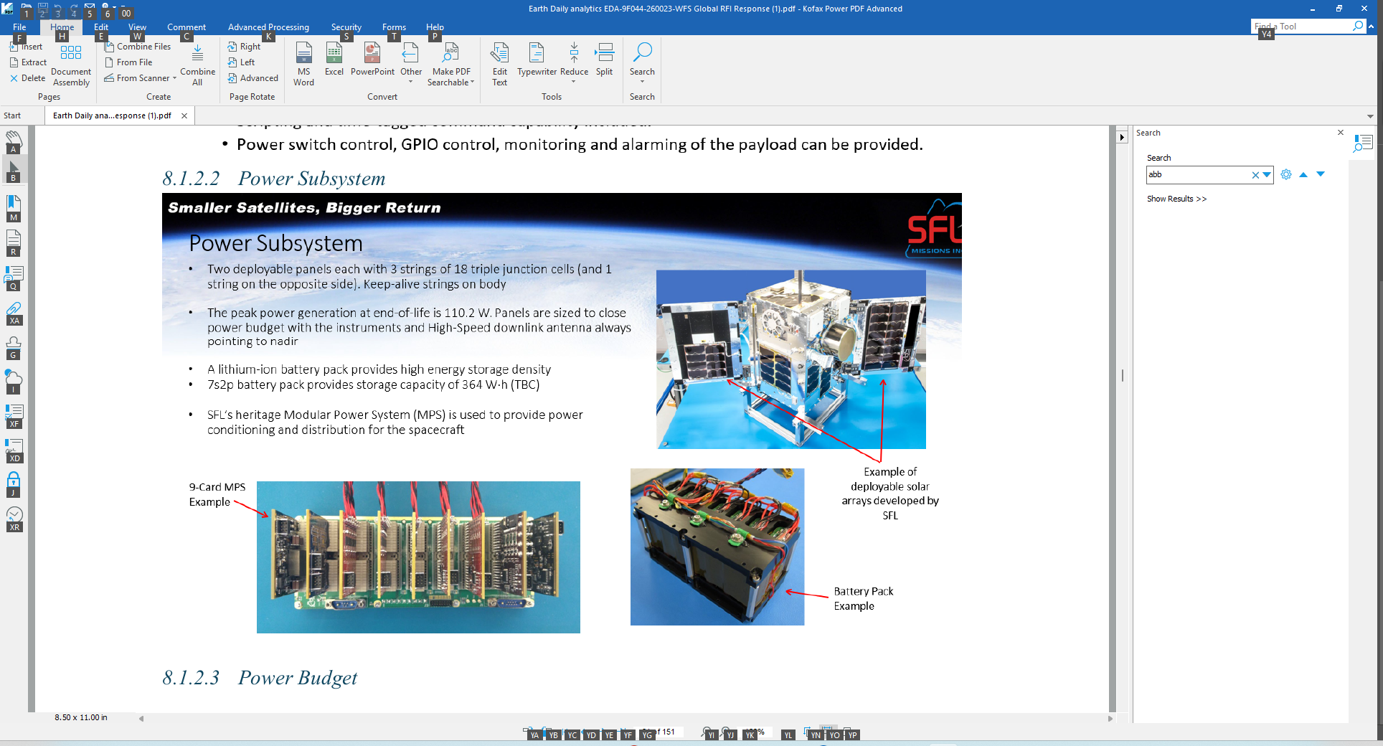  Example of Solar Panels on a cubeSat | Example of a 9-Card Power Control Unit | Battery Pack
Figure 2 – Notional spacecraft power-system examples

Command an Data handling

The Command and Data Handling (C&DH) subsystem will provide the central computing and data-management functions of each spacecraft.
The C&DH subsystem will:
- Receive and execute commands;
- Collect telemetry;
- Control payload interfaces;
- Manage mission data;
- Control onboard storage;
- Execute fault-management functions;
- Monitor spacecraft health;
- Support autonomous operation;
- Manage spacecraft configuration;
- Maintain mission timing; and
- Interface with the TT&C subsystem.
Each spacecraft shall provide at least 1 TB of usable onboard mission-data storage.
The C&DH subsystem shall support at least 72 hours of autonomous spacecraft operation without ground intervention. With a two-spacecraft constellation, the minimum total onboard storage is therefore 2 TB across the mission. The planning case of 125 GB/day of downlinked mission data per spacecraft corresponds to roughly 8 days of storage at full-rate-equivalent volume before accounting for compression, prioritization, and additional operational constraints.
Fault Management
The C&DH architecture will provide fault detection and recovery functions.
Potential functions include:
- Watchdog monitoring;
- Health monitoring;
- Fault detection;
- Fault isolation;
- Fault recovery;
- Safe-mode entry;
- Redundant-equipment selection; and
- Recovery following loss of ground communications.
Data Management
The C&DH subsystem will receive mission data from the payload and store the data before transmission to the ground segment.
The design will consider:
- Payload data-generation rate;
- Observation duration;
- Number of observations;
- Onboard storage;
- Communications opportunities;
- Data compression;
- Data prioritization;
- Data latency; and
- Ground processing capacity.
Because the two spacecraft will operate as a coordinated constellation, configuration and software management shall ensure that both spacecraft remain compatible with the common mission architecture, software baseline, time reference, operational procedures, and mission-planning interfaces.

Thermal Subsystem
The Thermal Control Subsystem will maintain spacecraft and payload components within their qualified temperature limits.
The thermal environment will vary throughout the highly elliptical orbit.
Thermal analysis will therefore consider:
- Solar radiation;
- Earth infrared radiation;
- Albedo;
- Eclipse;
- Orbital position;
- Spacecraft attitude;
- Payload heat generation;
- Electronics dissipation;
- Communications equipment;
- Battery temperature; and
- Propulsion components.
The thermal architecture will use passive thermal-control techniques wherever practical.
Potential components include:
- Multi-layer insulation;
- Thermal coatings;
- Radiators;
- Thermal straps;
- Heat pipes;
- Heaters;
- Thermostats; and
- Temperature sensors.
Thermal Analysis
The spacecraft will undergo hot-case and cold-case orbital thermal analyses.
The analysis will establish:
- Component temperature ranges;
- Heater requirements;
- Radiator sizing;
- Thermal gradients;
- Payload thermal stability;
- Battery thermal limits; and
- Propulsion thermal constraints.
Cost Drivers
Thermal-system cost will be affected by:
- Payload heat generation;
- Spacecraft power;
- Radiator area;
- Heater requirements;
- Thermal stability requirements;
- Propulsion configuration;
- Thermal analysis complexity; and
- Environmental testing.

Attitude Determination and Control Subsystem
Attitude Determination & Control
- Coarse attitude determination will use sun sensors, a magnetometer, and rate sensing; fine attitude determination will use star trackers.
- Three-axis attitude control will use reaction wheels with magnetorquers for detumbling and momentum management. The architecture shall support the mission-pointing requirements during imaging and high-rate communications.
- Absolute pointing accuracy target: ≤0.05° during imaging operations.
- The spacecraft will use mission-pointing profiles appropriate to the HEO observation geometry rather than assuming permanent nadir pointing in every spacecraft mode.
- 3 vacuum core magnetorquers will be utilized.
- Orbit determination will use the onboard navigation solution. A preliminary real-time position-knowledge target of <10 m is retained from the reference design and is subject to validation through the final flight-dynamics and navigation analysis.
Orbit Determination
- Orbit determination will be done by obtaining position estimates from the onboard GPS receiver.
- Real-time orbit position knowledge of <10 m.
- GPS receiver will also provide time reference for the satellite.

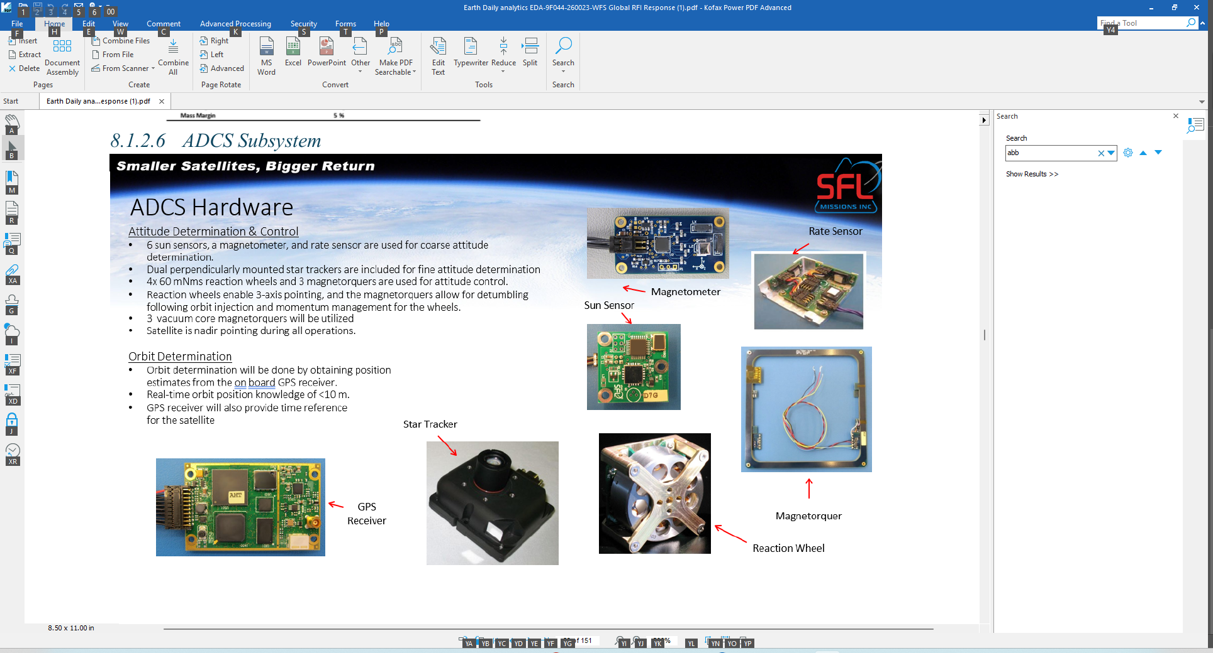  GPS Receiver | Magnetometer
Star Tracker | Magnetorquer
Sun Sensor | Rate Sensor
Reaction wheel

Propulsion subsystem
Propulsion System Characteristics
Parameter | Value | Units
Propellant Type | Iodine
Vacuum Specific Impulse (Isp) | 2192 | s
Vacuum Thrust | 1 | mN
Nominal Thrust | 1 | mN
Desired Propellant Contingency | 20%

Delta-V Budget
Item | Value
Orbit Keeping & Phasing | 40.0 m/s
Station Keeping | 10.0 m/s
Collision Avoidance | 40.0 m/s
Deorbit | 40.0 m/s
Delta-V Contingency | 16.6 m/s
Required Delta-V | 99.6 m/s

Notes
- Gridded Ion Thruster demonstrated on NorSat-TD.
- LTAN is uncontrolled and permitted to drift.
- Maneuvers consist of orbit raising or orbit lowering maneuver to enable orbit phasing, maintenance of ~550 km altitude and 5-year deorbit capability at end of life.

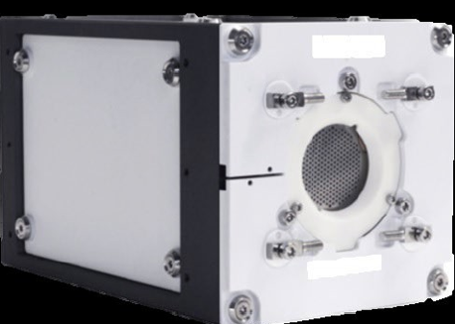
Figure 3 – Notional ADCS and propulsion components

TT&C
The Telemetry, Tracking and Command (TT&C) subsystem shall provide robust command, telemetry, timing, navigation, and high-rate mission-data communications for both spacecraft.
  - S-band command receiver
    - 32 kbps command uplink reference rate; final command-link margin to be verified by the link budget.
  - A pair of S-band patch antennas mounted on opposite faces of the spacecraft to provide omni-directional coverage
  - X-band mission-data transmitter
    - High-rate mission-data downlink target: ≥500 Mbps peak; effective end-to-end throughput shall be demonstrated through the final link budget, antenna configuration, ground-contact analysis, and data-volume model.
    - Reference X-band RF output power: 700 mW for the heritage telemetry transmitter; the high-rate mission-data transmitter power is TBD from the final link budget.
  - A pair of X-band patch antennas mounted on opposite faces of the spacecraft to provide omni-directional coverage
- The ground receiving system is assumed to use a commercial station architecture; the current reference includes a 3.7 m-class antenna. Final station count and location shall be sized to support the two-spacecraft HEO contact geometry and the 125 GB/day-per-spacecraft planning case.

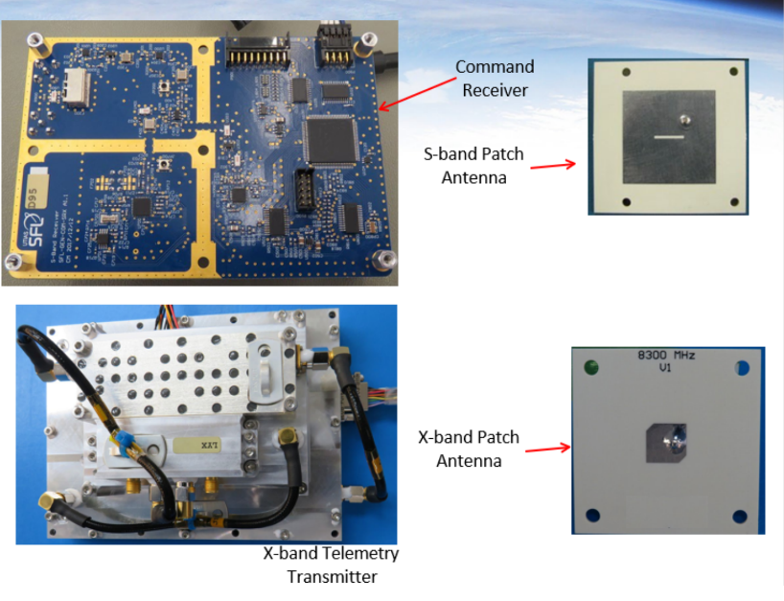
Reference TT&C link-budget inputs
S-band command uplink reference frequency: 2065 MHz.
- S-band command path shall maintain required command and telemetry availability for 24-hour government operations.
- Transmit power 20,000 mW
X-band mission-data downlink reference frequency: 8309 MHz.
- X-band transmit power and modulation/coding shall be selected from the final link budget; the earlier low-rate telemetry values are not treated as the SAM mission-data throughput requirement.
- Mission-data downlink sizing shall be reconciled with the 125 GB/day-per-spacecraft planning case and the 6-hour priority-data latency requirement.

Payload
Source: EDA reference payload material
Each payload consists of:
- A VNIR imager
- A SWIR imager
- An onboard calibration reference / calibration subsystem
- A payload electronics unit

VNIR Imager
The VNIR imager will provide the primary visible and near-infrared imaging capability for SAM. The instrument will be used for wide-area observation of Arctic land, sea ice, coastal regions, infrastructure, and maritime activity. The final instrument will be selected based on spatial resolution, field of view, sensitivity, data rate, mass, power consumption, calibration stability, and compatibility with the selected HEO observation geometry.
A preliminary commercial/flight-ready camera candidate remains the Raptor Photonics Hawk 1920, used only as a reference instrument for early mass, optical, detector, and data-rate trades.
Raptor Photonics Hawk 1920
Parameter | Hawk 1920
Detector | Sony Pregius CMOS
Resolution | 1944 × 1472 pixels
Pixel pitch | 4.5 µm
Spectral response | Approximately 0.3–1.1 µm
Frame rate | Up to 50 Hz
Shutter | Global shutter
Camera mass | Approximately 115 g
Camera dimensions | Approximately 48 × 43 × 43 mm
Interface | Camera Link
Application | VIS–NIR imaging; flight-ready version offered
Mass of camera | 115 g

The Hawk 1920 remains a candidate reference instrument rather than a final payload selection. Its characteristics are not treated as SAM requirements; final payload performance must be demonstrated against the SAM mission requirements and selected HEO geometry.
The final VNIR architecture shall be derived from the required ≤5 m GSD, ≥50 km swath, radiometric performance, geolocation accuracy, field-of-view, data-rate, mass, power, and calibration requirements.

The SWIR imager will complement the VNIR instrument by providing additional information for distinguishing snow, ice, water, exposed land surfaces, and other Arctic environmental features.
The SWIR imager will complement the VNIR instrument by providing observations in the short-wave infrared portion of the spectrum. SWIR observations will provide additional information for distinguishing snow, ice, water, exposed land surfaces, and other Arctic environmental features.
The final SWIR instrument has not yet been selected. A representative flight-qualified or modified-COTS instrument will be identified during the payload trade study and must satisfy the required spatial, radiometric, mass, power, and integration constraints.

Parameter | Preliminary SAM Requirement / Target
Spectral range | SWIR; final range TBD
Detector technology | To be determined through payload trade
Spatial resolution | GSD ≤5 m under defined reference imaging conditions
Field of view | TBD from HEO geometry and swath requirement
Frame rate | TBD from observation mode and data-rate analysis
Interface | Spacecraft payload-data interface
Camera mass | Within ≤150 kg payload allocation
Power consumption | Within payload power allocation; target ≥500 W continuous / 750 W peak allocation
Data rate | TBD; must support the mission-data volume and ground latency requirements
Application | Arctic surface, ice, snow, water, and maritime characterization
Flight qualification | Required prior to flight

Payload Electronics
The payload electronics will provide the interface between the imaging instruments and spacecraft C&DH. The electronics will handle instrument control, detector readout, timing, data formatting, compression/pre-processing, buffering, health monitoring, and transfer of mission data into the spacecraft data chain.
Parameter | Preliminary SAM Requirement / Target
Primary function | Instrument control and mission-data handling
Detector interface | Instrument dependent
Spacecraft interface | C&DH payload-data interface
Data processing | Formatting and optional compression/preprocessing
Data buffering | Required
Timing | Synchronized spacecraft/instrument timing
Health monitoring | Required
Mass | TBD
Power consumption | TBD
Data throughput | TBD based on final payload configuration
Radiation tolerance | Suitable for selected HEO environment

Onboard blackbody calibration
The payload will include an onboard calibration capability to maintain measurement quality throughout the mission.
For the VNIR and SWIR instruments, calibration will use appropriate onboard references and/or periodic calibration observations. A thermal-IR blackbody is not part of the baseline and would only be evaluated if the payload trade study introduces a thermal-IR instrument.
Parameter | Preliminary SAM Requirement / Target
Calibration type | Radiometric and geometric
VNIR calibration | Onboard reference and/or periodic calibration observations
SWIR calibration | Onboard reference and/or periodic calibration observations
Thermal calibration | Blackbody reference if thermal IR instrument is selected
Calibration frequency | TBD
Instrument monitoring | Required
Long-term degradation monitoring | Required
Ground-processing interface | Calibration data incorporated into product generation
Mass | TBD
Power consumption | TBD

Launch Segment Description
The preliminary spacecraft mass allocation implies a combined launch mass of ≤1,200 kg for the two spacecraft, with a target combined spacecraft mass of approximately 1,000 kg before any launch adapter/dispenser allocation. Final launch-vehicle sizing shall use the verified flight mass properties and applicable launch margins.
The two SAM spacecraft will be launched using a single commercial launch service into the selected HEO configuration. Northern Launch Services is the current launch-service organization in the procurement baseline; final launch-vehicle selection remains subject to launch-interface and orbit-insertion analysis.
The launch estimate shall treat launch insurance as a separate cost element because the reference launch price excludes insurance.
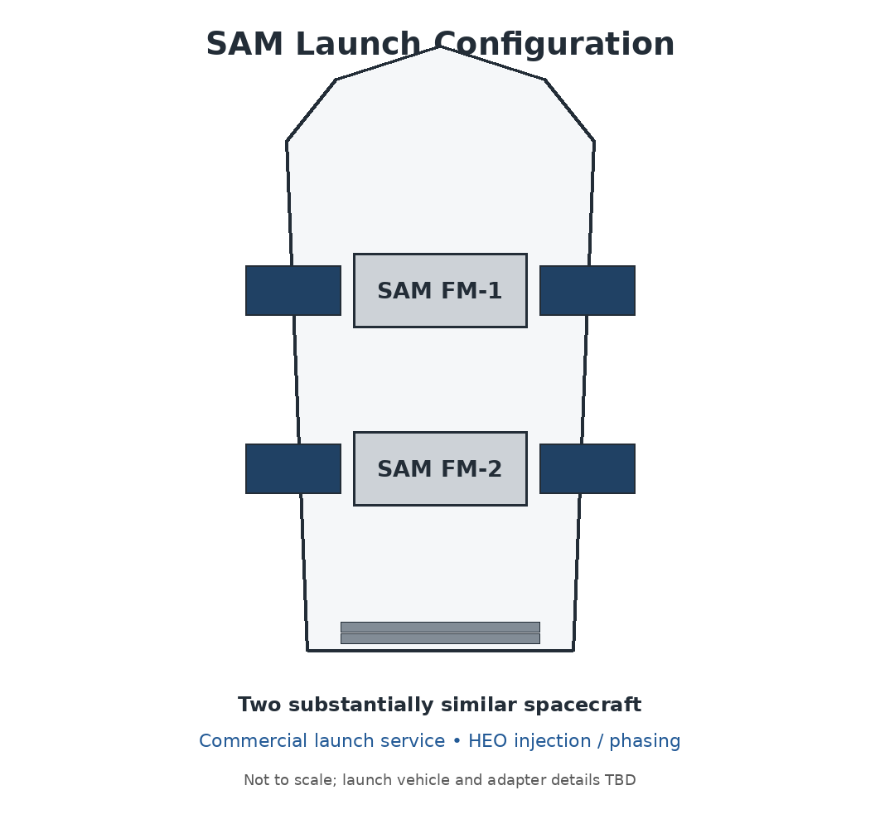
Figure 4 – SAM Two-Spacecraft Launch Configuration
Alternate launch services may be considered if required by availability, orbit insertion performance, schedule, cost, or technical compatibility.
- The launch-service down-select shall preserve compatibility with the two-spacecraft constellation, launch-site processing, spacecraft separation interfaces, and HEO injection/orbit-phasing requirements.
- The commercial launch campaign is planned to begin after flight-unit completion and shall be completed within the baseline launch-readiness window established in Part C.
- Launch preparation shall include transportation, launch-site inspection, final functional checks, configuration verification, and readiness reviews.
- Post-launch operations shall transition into LEOP and commissioning with government mission operations support and contractor technical assistance.

Ground Segment and Mission Operations
The proposed baseline solution is for the Government of Canada to provide the Mission Planning System (MPS) and perform mission operations, while Earth Daily Analytics provides and integrates the required ground-segment elements. The ground segment supports command and control of both SAM spacecraft, high-rate mission-data reception, processing, calibration, quality control, archiving, and secure dissemination to authorized users.
Ground Segment Element | Description
Mission Planning System | Government-provided system generating observation schedules and spacecraft command timelines using spacecraft constraints, orbital position, payload availability, and mission priorities to coordinate the two spacecraft.
Spacecraft Control System | Command, telemetry, spacecraft monitoring, health management, and control functions for both SAM spacecraft.
Receiving Stations | Receiving network providing telemetry reception, command uplink, and high-rate X-band mission-data downlink sized for the two-spacecraft HEO contact geometry.
Spacecraft Operations | Government-operated 24-hour mission operations including spacecraft monitoring, commanding, anomaly response, orbit and attitude monitoring, mission planning, and constellation coordination.
Data Processing, Archiving and Dissemination | Mission data are processed, calibrated, quality-checked, archived, and securely distributed to authorized Government of Canada users and other approved users. Priority product latency is ≤6 hours after raw-data receipt.
Data Volume / Availability | Planning case of ~125 GB/day per spacecraft; ground processing ≥1 TB/day raw-data-equivalent; ground-system availability ≥99% during scheduled operations.

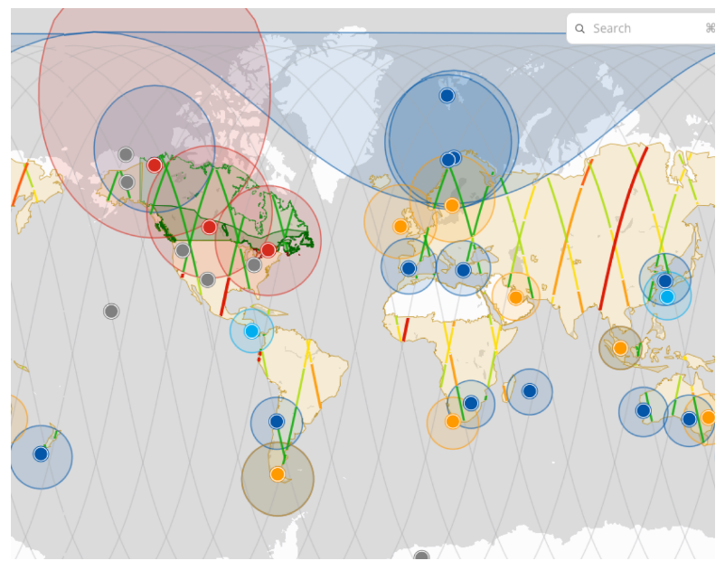
Figure 5 – Ground Receiving Stations
At 250 GB/day of combined downlinked data, five years of continuous operation corresponds to approximately 456 TB of raw downlinked volume before compression, reprocessing, products, metadata, and redundancy. A preliminary 2 PB archive planning capacity therefore provides roughly 4.4 times the five-year raw downlinked volume, while the ≥1 TB/day processing capacity provides approximately four times the nominal daily downlinked volume for reprocessing, calibration, and product-generation headroom.
The current planning case is 125 GB/day of downlinked mission data per spacecraft, or approximately 250 GB/day for the two-spacecraft constellation. Ground processing is preliminarily sized at ≥1 TB/day of raw-data-equivalent capacity to provide margin for reprocessing, priority products, calibration, and product generation.

Systems Engineering and Project Management Approach

SAM will use heritage evidence where applicable, but the finalized baseline is not assumed to inherit the TRL of any reference spacecraft or instrument. Major spacecraft-bus components are targeted to reach TRL ≥8 before flight qualification. Critical payload technologies should be at least TRL 6 at the start of B2 development and TRL ≥8 before flight qualification. Commercial or heritage qualification evidence may be reused only where the configuration, environment, interfaces, and operating assumptions are shown to be applicable to SAM.

Phasing Logic and Naming conventions
For the finalized CADRe cost baseline, the PM nomenclature is B1, B2, C, D, E, and F. The nominal schedule is: B1 = 13 months (September 2026–October 2027); B2 = 9 months (October 2027–July 2028); C = 9 months (July 2028–April 2029); D = 25 months (April 2029–May 2031, including manufacturing, integration, test, launch and commissioning activities); E = 60 months (May 2031–May 2036); F = approximately 2 months for disposal/close-out. Thus, the nominal PM schedule contains 116 months from B1 start through the end of nominal operations, followed by a separate approximately 2-month Phase F close-out period. The detailed optimistic and pessimistic scenarios remain controlled in CADRe Part C and are not duplicated here.
PREP 1 | Prototyping Activities (before Gate 1)
PREP 2 | Prototyping Activities (during Phase 0/A)
Phase 0 | Concept & Feasibility Studies
Phase A | System Definition
Phase B | Preliminary Design
Phase C | Detailed Design
MAIT | Manufacturing, Assembly, Integration and Test (of Systems, Subsystems and Components)
SAIT | Segment Level Assembly, Integration and Test (begins with System Integration review)
LEOP | Launch and Early Operations (incl. commissioning)
Phase E | Nominal Operations (per design life)
Phase X | Extended operations (mission extension)
Phase F | decommissioning and disposal

CSA PRoject Milestones
The finalized PM schedule is the nominal baseline for this CADRe Part A. It establishes instrument and spacecraft milestones used to determine CSA need dates and is consistent with the current Part C phase-duration and PM scenario baseline.
Instrument / PM Phase | Gate / Milestone | Major Milestone | Milestone Date
B1 | MCR | Mission Concept Review | 29 March 2027
B1 | CA | Contract Award | 1 October 2027
B2 | PL-PDR | Payload Preliminary Design Review | 1 April 2028
B2 | BUS-PDR | Bus Preliminary Design Review | 1 July 2028
B2 | PDR | Overall Preliminary Design Review | 1 July 2028
C | PL-CDR | Payload Critical Design Review | 1 January 2029
C | BUS-CDR | Bus Critical Design Review | 1 April 2029
C | CDR | Overall Critical Design Review | 1 April 2029
D | MRR | Manufacturing Readiness Review | 1 June 2029
D | PL-1 | Payload 1 Ready for Integration | 1 August 2029
D | FLATSAT | Flatsat Integration & Test | 1 October 2029
D | FHT | Flight Hardware Complete | 1 April 2030
D | ETRR | Environmental Test Readiness Review | 1 May 2030
D | AR/SAR | Acceptance Review | 1 September 2030
D | LRR | Launch Readiness Review / Flight Units Complete | 1 November 2030
D | L | Launch | 1 January 2031
D | CCR | Commissioning Review | 1 April 2031
D | LEOP | LEOP & Commissioning Complete | 1 April 2031
D | D-END | Phase D End | 1 May 2031
E | OPS | Start of Nominal Operations | 1 May 2031
E | EOM | End of Nominal Operations | 1 May 2036
F | EOL | Phase F disposal/close-out end | 1 July 2036

Safety and Mission Assurance
Initial assessment: Mission Class B. The program requires formal mission assurance, qualification, acceptance, verification, configuration control, and readiness reviews. Safety and mission-assurance effort is a direct cost and schedule driver because both flight spacecraft must independently demonstrate conformity with the qualified design before launch.

Qualification and Acceptance Strategy, MODEL Philosophy
The SAM qualification and acceptance strategy will verify that both spacecraft are capable of surviving launch and performing their required mission functions throughout the planned operational lifetime. The approach uses one Qualification Model (QM) followed by two flight models (FM-1 and FM-2), with engineering-model hardware used only where necessary to verify interfaces and reduce development risk.
The Qualification Model will represent the flight configuration as closely as practical and will undergo spacecraft-level environmental and functional testing, including vibration, thermal-vacuum, electromagnetic compatibility, and end-to-end functional testing. Payload interfaces, communications, C&DH, power, attitude control, propulsion, mission-data handling, and ground interfaces will be verified. Existing qualification evidence may be used only where applicable to the SAM configuration and operating environment.
Following successful qualification, FM-1 and FM-2 will be manufactured using the qualified design. Each flight spacecraft will undergo its own functional, electrical, communications, payload, software, and appropriate environmental acceptance testing. FM-2 is not qualified solely by FM-1 testing; both spacecraft must independently demonstrate conformity with the qualified design before launch.
The qualification and acceptance program also accounts for the logistics of operating two spacecraft. The spacecraft will be integrated and tested individually, transported to the launch site under controlled configuration and environmental conditions, and supported through launch-site inspection, final functional checks, propulsion servicing if applicable, launch readiness activities, and secure transfer of configuration data.
Following launch, each spacecraft will undergo an individual commissioning period targeted to complete within 90 days of launch. Commissioning will verify deployment, power generation, attitude control, communications, payload functionality, calibration, initial imaging performance, flight-software configuration, and ground-segment interfaces before the spacecraft are transitioned into coordinated nominal operations.
All qualification and acceptance results will be documented through the SAM verification and configuration-management process. Any anomalies identified during testing, transportation, launch-site processing, or commissioning will be assessed and resolved before the affected spacecraft is declared operational. Final approval for launch and entry into operational service will be based on completion of required verification activities and successful Flight Readiness and Operations Readiness Reviews.

The current CADRe Part C risk register and Risk Breakdown Structure are the controlling programmatic risk references. Cost and schedule risks of particular importance to Part A are payload-to-bus integration, procurement and long-lead items, spacecraft manufacturing and environmental testing, launch availability, two-spacecraft technical coordination, ground-segment capacity, operations staffing, requirements growth, and commissioning delay. Risk treatment is linked to the nominal, optimistic, and pessimistic PM schedule scenarios used for sensitivity analysis.
The project team shall produce a risk register (ref CADRe part C)

Organizational Breakdown Structure
CSA Project Team: mission authority and program manager; responsible for systems engineering, payload, program management, technical authority, mission integration, mission planning, and government operations.
- DND: principal defence stakeholder and operational user; provides defence-related mission priorities, operational requirements, and authorized use requirements.
- Payload: CSA; payload electronics: CSA.
- Detector: NorthStar Imaging Technologies.
- Bus: Canadian Orbital Systems (COS), selected spacecraft-bus contractor.
- Ground segment: Earth Daily Analytics (EDA), responsible for provision and integration of required ground-segment elements.
- Launch: Northern Launch Services. Science Segment: Canadian university/research institutions. No international mission partner is assumed in the baseline.

Appendices

Acronym List

Acronym | Definition
CADRe | Cost Analysis Data Requirement
CSA | Canadian Space Agency
DND | Department of National Defence
EDA | Earth Daily Analytics
COS | Canadian Orbital Systems
NLS | Northern Launch Services
EO | Earth Observation
HEO | Highly Elliptical Orbit
VNIR | Visible and Near-Infrared
SWIR | Short-Wave Infrared
C&DH | Command and Data Handling
ADCS | Attitude Determination and Control System
TT&C | Telemetry, Tracking and Command
MPS | Mission Planning System
SCS | Spacecraft Control System
MCR | Mission Concept Review
PDR | Preliminary Design Review
CDR | Critical Design Review
MRR | Manufacturing Readiness Review
ETRR | Environmental Test Readiness Review
AR/SAR | Acceptance Review / System Acceptance Review
LRR | Launch Readiness Review
CCR | Commissioning Complete Review
LEOP | Launch and Early Orbit Phase
MAIT | Manufacturing, Assembly, Integration and Test
SAIT | Spacecraft/Segment Assembly, Integration and Test
TRL | Technology Readiness Level
QM | Qualification Model
FM | Flight Model
GSD | Ground Sample Distance
PCRA | Project Complexity and Risk Assessment

